MICRO-PROJECT REPORT

**“SUPER-MARKET BILLING SYSTEM’’**

Under the subject

GUI Application Development using VB.Net

Submitted by

|  |  |
| --- | --- |
| Sr No. | Student name |
| 1 | Shruti Vishnu Gatkal. |

Under guidance of

**Mrs.Korade L.S.**

Department of Computer Engineering

Government Polytechnic, Karad.

MICRO-PROJECT REPORT

**“SUPER-MARKET BILLING SYSTEM’’**

**1.0 Rationale:**

The project is on Supermarket Billing. Supermarket is the place where customers come to purchase their daily using products and pay for that. So there is a need to calculate how many products are sold and to generate the bill for the customer. In our project we have three users. First is data entry operator who will enter the products in database. Second one is the administrator who will decide the taxes and commissions on the products and can see the report of any product. Third one is the bill calculating operator who will calculate the bill and print.

**2.0 Aims/ Benefits of Micro-Project:**

1) To study the concept of GUI application using VB.Net.

2) To develop windows form application using visual studio 2013.

3) To manage billing efficiently for supermarket.

4) To understand the database connectivity within vb.net and Access.

**3.0 Course Outcomes:**

1) Use visual studio IDE to design application.

2) Develop GUI application using Form control and its events.

3) Use Data access control to store data in database and retrieve it.

4) Use Data Binding in GUI Application.

**4.0 Actual procedure followed:**

Thereare 6 windows application forms. These are as follows:

1. Introductory window.
2. Login window.
3. Home.
4. Create a new bill.
5. View old bills.
6. Add new items

* **Algorithm:**

1. Project execution starts from “Login” window which ask about correct password. By entering correct password system’s home page will displayed.
2. On the “Home” page different option are present. We can select the option according to our choice.
3. ‘Create new bill’ function required customer product list and calculate total bill by entering product name and quantity. Function calculates total price and add to the database with customer name.
4. ‘Add new item’ function adds new item information to the stock database of the system by entering item name, ID and quantity.
5. ‘View old bill’ function displays old bill from supermarket database.

* **Level 0: Data Flow Diagram:**

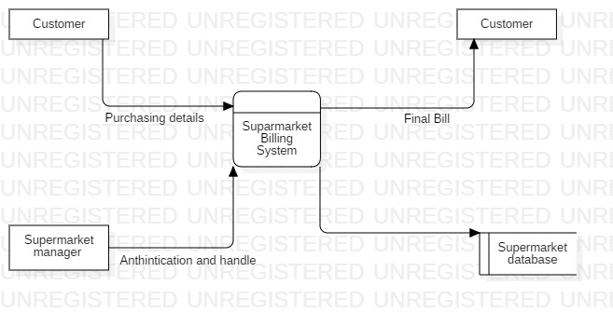

* **Level 1: Data Flow Diagram:**

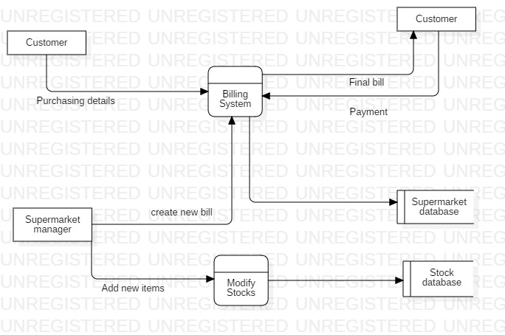

**6.0 Actual Resource Used:**

|  |  |  |  |
| --- | --- | --- | --- |
| **Sr No.** | **Name of resource/ material** | **Specification** | **Remark** |
| 1] | Laptop | Intel(R)Core (TM) i36006 U CPU @2.00GHz 2.00 |  |
| 2] | Software | Visual Studio 2013(Ultimate) |  |
| 3] | Other references | http://www.tutorialspoint.com/vb.net/ |  |

**7.0 Output of the Micro-Project:**

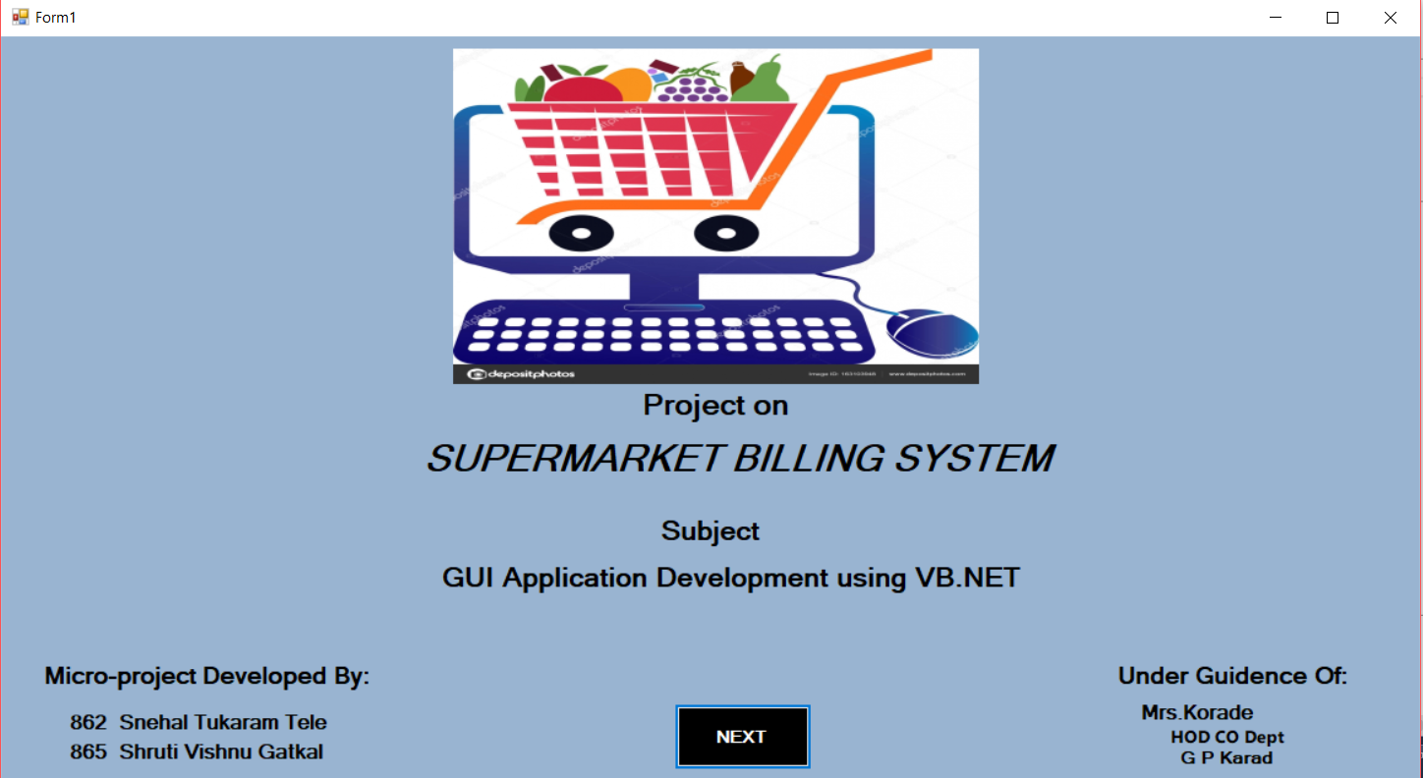

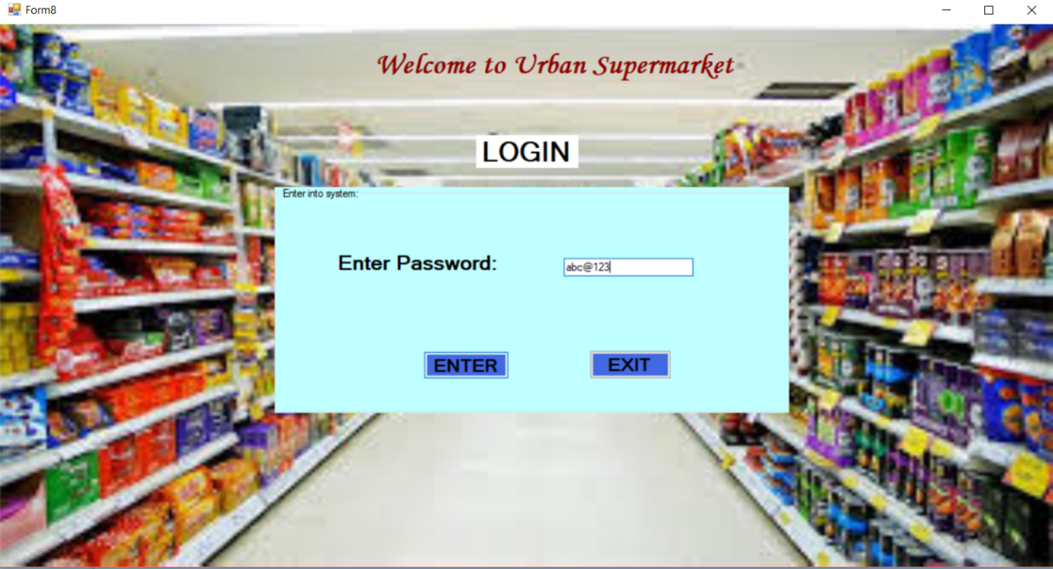

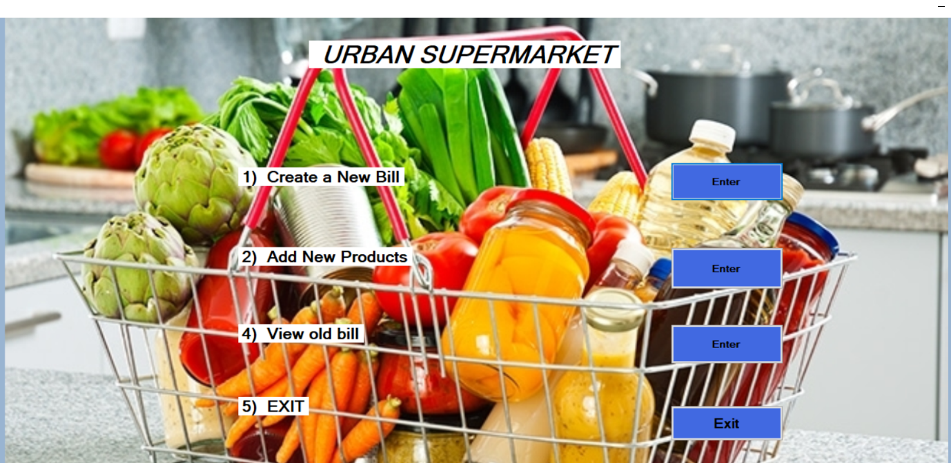

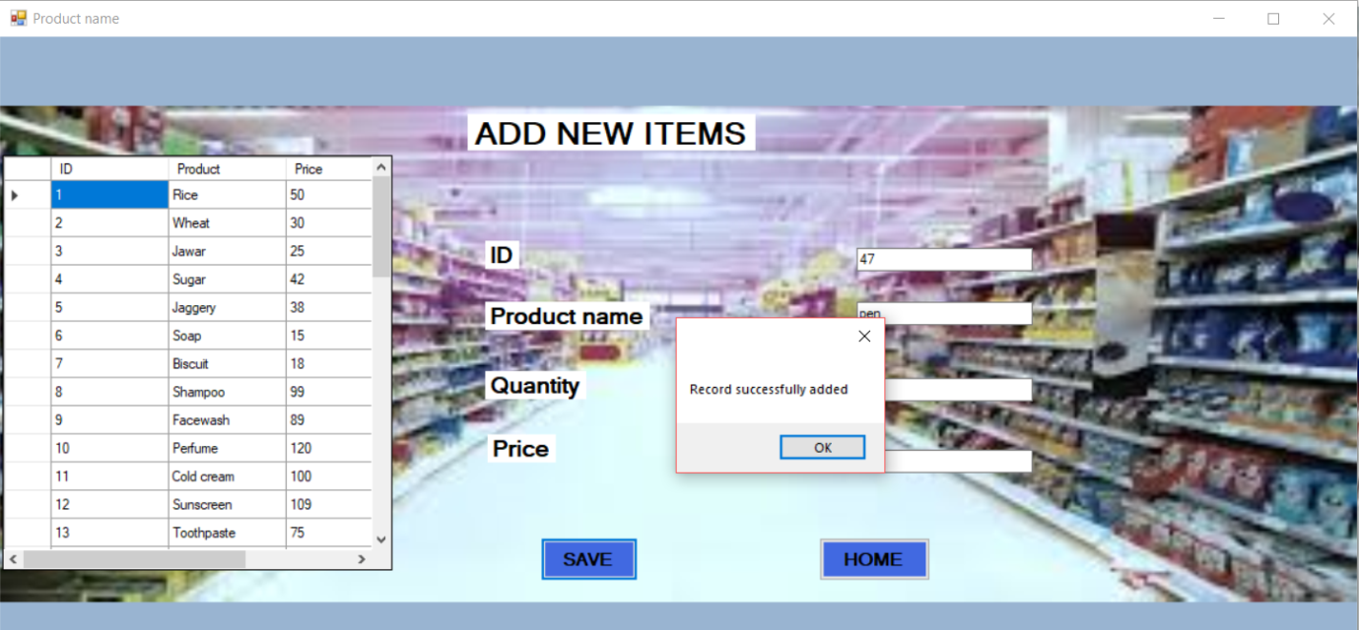

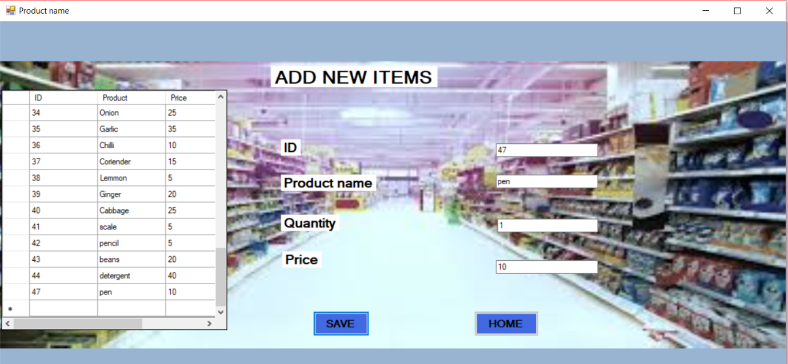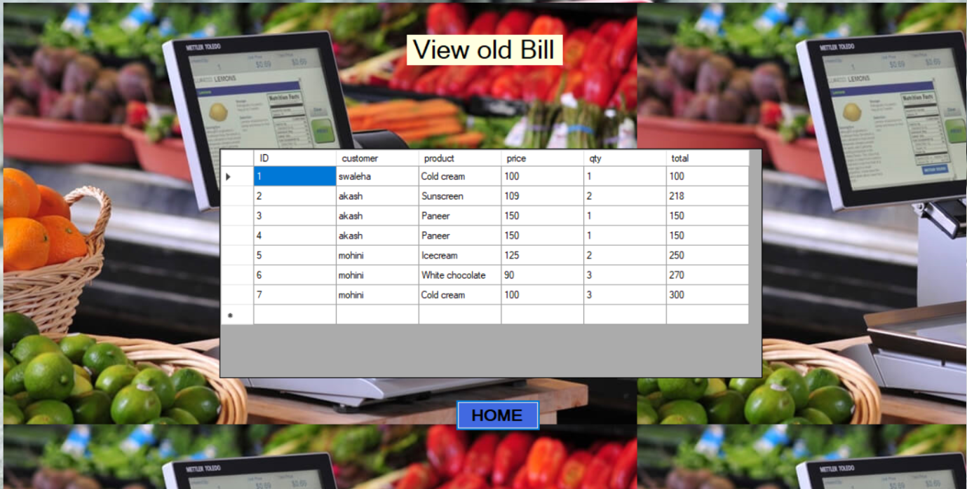

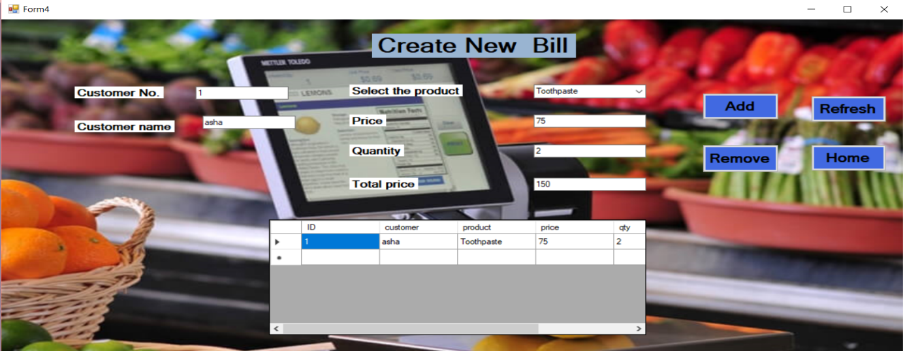

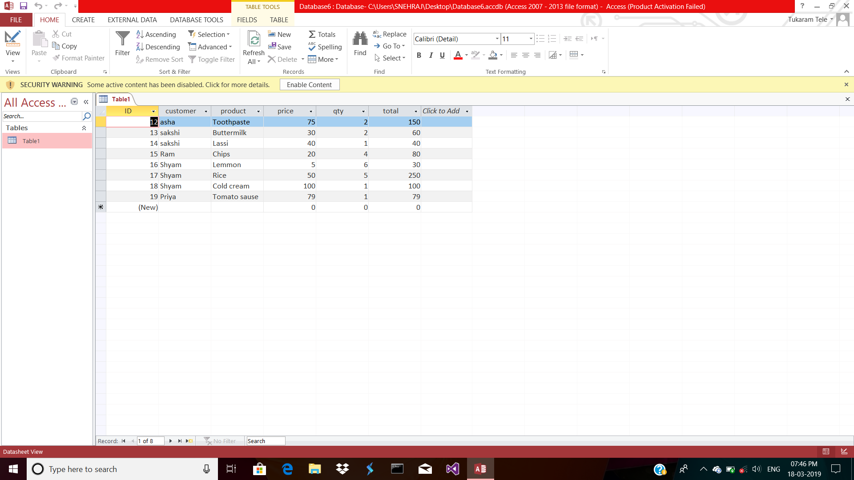

**8.0 Skill Developed / Learning outcomes of micro-project:**

1) We understand about graphic user interface.

2) We understood database connectivity within window form and Access database.

3) We learned, functions and need of oledb-connection, dataset, data-adapter

4) We successfully developed a windows application project in VB.Net.

5) We learned about Visual studio 2013 software.

1. **Application of this Micro-project**
2. Supermarket billing system can be used to manage billing process.
3. This system reduces manager efforts and time required for the huge calculation.
4. This system also used to manage stocks of supermarket.